Iron Devils Scouting App

1. Prerequisites:

* Windows + MS Excel
* Android devices and usb cables with **USB dedugging enabled**
* Iron Devils scripts/Excel documents
* adb installed/**able to use as environment variable** - see getadt.bat for download link, we cannot include the it due to Google's terms
  + (see http://www.redmondpie.com/how-to-set-up-android-adb-and-fastboot-on-windows-tutorial/ for a good tutorial)
  + test by opening command prompt and typing "adb devices" (no quotes), should display a device if connected

After downloading from the Iron Devils website, the zip file can be extracted anywhere. You will have a folder similar to this. 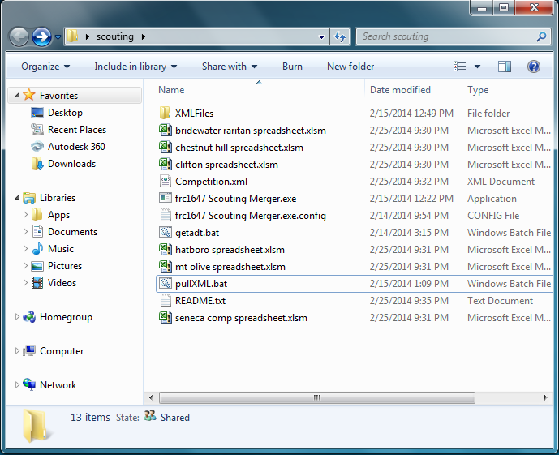

To start, get the app installed on your devices. Sources are/will be Google Play and this folder.

1. Connect a tablet via USB, to pull data open the pullXML.bat. Be sure to let the file run.
2. Press a key to get started. In this case, an error occurred. 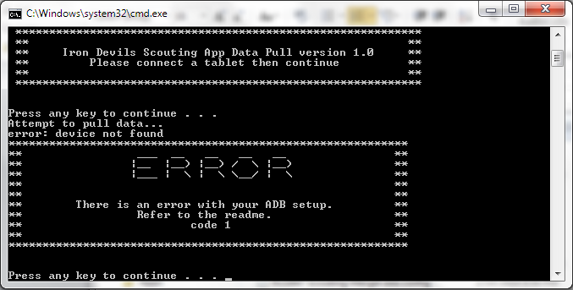Right above the big error message is the type/reason an error occurred.
3. After a successful data pull, a window will open as follows. This can also be accessed by opening the exe file in the scouting folder. 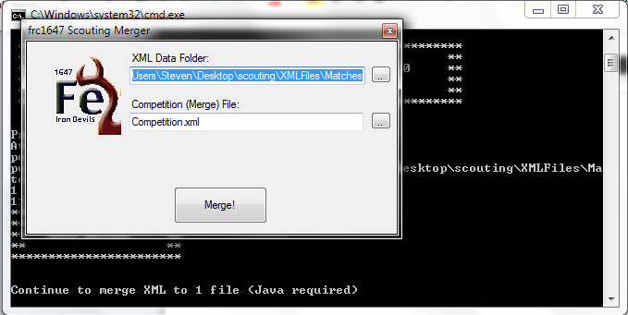If you are coming from the batch file, these will be preloaded. Just hit merge and be ready. Otherwise, select the XMLFiles directory up top and the Competition.xml file for the bottom.
4. Continuing with the batch execution, Excel will open. It will open an Excel file called scouting.xlsm **ONLY**. No file is currently called that, rename one to be scouting.xlsm (macro-enabled). When Excel opens, there may be a few security warnings. Enable editing, then macros. A window like the following will appear to select the Competition.xml file. Excel will be doing many calculations, please expect it to be slow. During our tests, the Excel screen stopped responding for a bit, appeared to have no file open, and then the data appeared.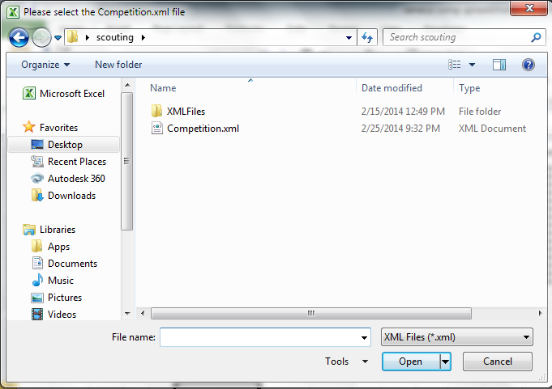
5. Go to the 3rd tab in Excel and customize the weightings. Hit the button to get customized rankings for what teams you should pick for alliances.

More information regarding setup/troubleshooting is available in the readme document.